5.4 Snippet Generator

This section will guide you to:

* Generate a step snippet with the Snippet Generator

This lab has one sub-section, namely:

5.4.1 Generating Pipeline code with Snippet Generator

**Step 5.4.1:** Generating Pipeline code with Snippet Generator

* Navigate to the Pipeline Syntax link (referenced above) from a configured Pipeline, or at ${YOUR_JENKINS_URL}/pipeline-syntax.
* Select the desired step in the Sample Step dropdown menu
* Use the dynamically populated area below the Sample Step dropdown to configure the selected step.
* Click Generate Pipeline Script to create a snippet of Pipeline which can be copied and pasted into a Pipeline.

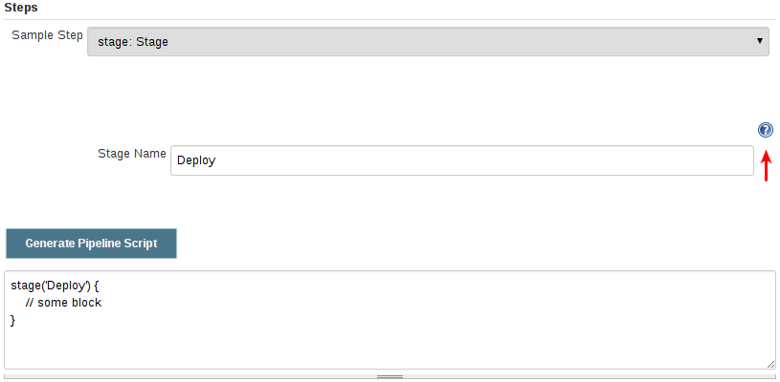

* To access additional information and/or documentation about the step selected, click on the help icon (indicated by the red arrow in the image above)